流行病學與生物統計計算Homework 7

學號：b07401048 系級：醫學五 姓名：賴柏瑞

**# Homework7**

**#EX 18_1**

*# HW7*

*# Ex 18_1*

*# plot log-likelihood of for mean of a Poisson dis.*

**llpois** <- function(data, param) {

ans <- 0

param <- lambda

for (i in 1 : **length**(data)) {

ans <- ans + **log**(((**exp**((-1) * lambda) * (lambda ^ data[i])) / **factorial**(data[i]))) *#nolint*

}

return(ans)

}

x1 <- **c**(5, 5, 6, 0, 1, 2, 4, 4, 3, 5, 7, 10)

lambda <- **seq**(0, 10, by = 0.01)

llpois1 <- llpois(data = x1, lambda)

**png**(filename = "hwk7.1.png", width = 1000, height = 1000, res = 200)

**plot**(lambda, llpois1, col = 1, type = "l", lwd = 3)

**dev.off**()

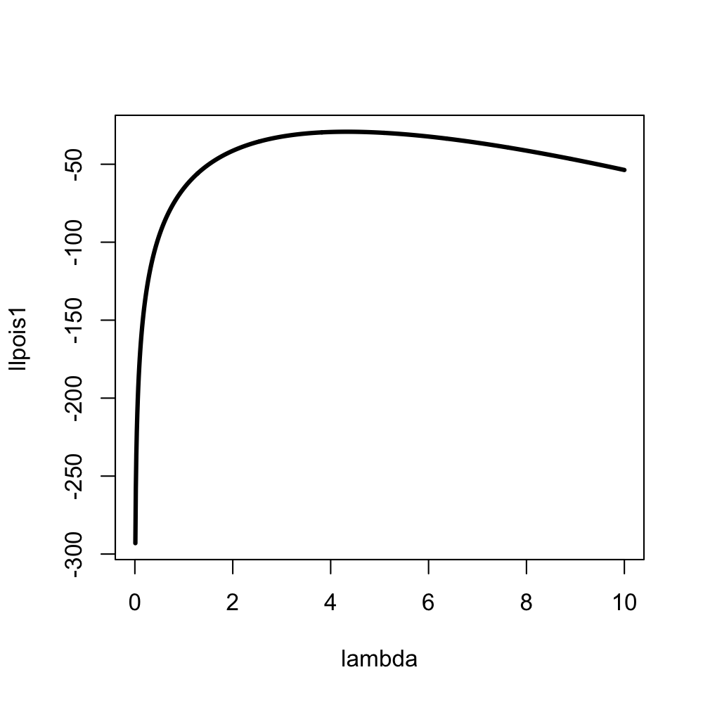

*# maximum likelihood estimate of lambda by Newton-Raphson*

*# finding suitable x0*

x <- **c**(5, 5, 6, 0, 1, 2, 4, 4, 3, 5, 7, 10)

f <- (-**length**(x)) + (**sum**(x) / lambda)

lambda <- **seq**(0, 10, by = 0.01)

**png**(filename = "hwk7.2.png", width = 1000, height = 1000, res = 200)

**plot**(lambda, f, col = 1, type = "l")

**abline**(h = 0, col = 2)

**dev.off**()

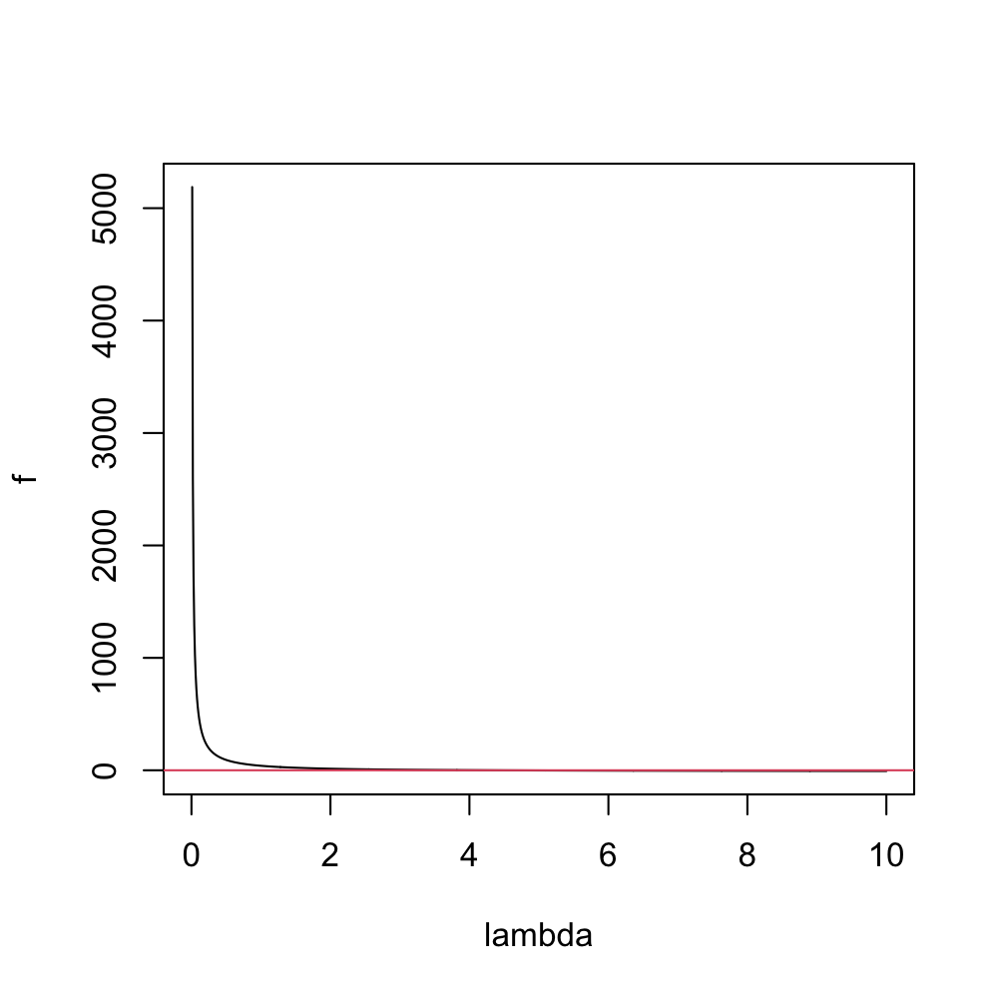

*# constructing ftn*

**ftn** <- function(lambda) {

x <- **c**(5, 5, 6, 0, 1, 2, 4, 4, 3, 5, 7, 10)

f <- (-**length**(x)) + (**sum**(x) / lambda)

df <- -(lambda ^ (-2)) * **sum**(x)

return(**c**(f, df))

}

*# Newton-Raphson method*

**root** <- function(ftn, x0, tol, max_iter) {

x <- x0

y <- ftn(x)

iter <- 0

while ((**abs**(y[1]) > tol) && (iter < max_iter)) {

x <- x - y[1] / y[2]

y <- ftn(x)

iter <- iter + 1

**cat**("at iteration", iter, "value of x is", x, "\n")

}

if (**abs**(y[1]) > tol) {

**cat**("algorithm failed to converge\n")

return(NULL)

} else {

**cat**("algorithm converges to \n")

return(x)

}

}

root(ftn, x0 = 3, tol = 1e-09, max_iter = 100)

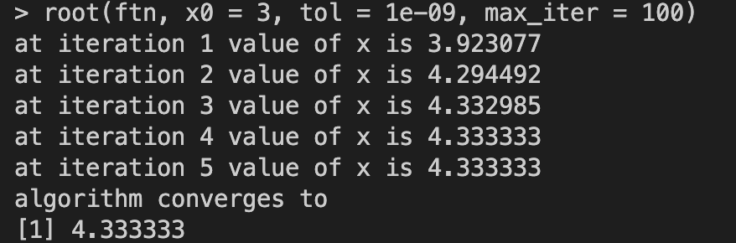

**# EX S5_1**

*# EX S5_1 BMI3 ~ SEX + AGE + Treatment*

**setwd**("/Users/raymond/Desktop/R/course/data/")

data <- **read.csv**("/Users/raymond/Desktop/R/course/data/BMIrepeated.csv")

**dim**(data)

**head**(data)

**mode**(data$SEX) *# data$SEX is character, so i have to convert it to numeric*

*# convert sex to numeric, setting "M" be 1, "F" be 0*

datama <- **as.data.frame**(data)

for (i in 1 : **length**(data$SEX)) {

if (datama[i, 2] == "M") {

datama[i, 2] <- 1

} else {

datama[i, 2] <- 0

}

}

**head**(datama)

(sex <- **as.numeric**(datama[, 2]))

*# design matrix*

x <- **cbind**(**rep**(1, **length**(data$BMI3)), sex, data$AGE, data$Treatment)

**head**(x)

*# regression coefficients*

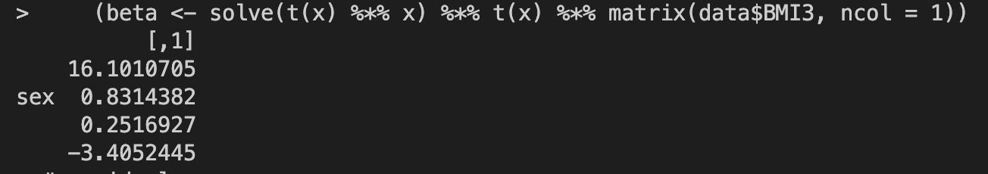 beta <- **solve**(**t**(x) %*% x) %*% **t**(x) %*% **matrix**(data$BMI3, ncol = 1)

*# residual*

residual <- data$BMI3 - x %*% beta

*# sigma square*

 sigmasqr <- **sum**(residual ^ 2) / **length**(data$BMI3)

*# log likelihood*

(lldata <- (-**length**(data$BMI3) / 2) * (**log**(2 * pi) + **log**(sigmasqr) + 1))

